Unit 2 – Power Tools

**3.2.0 Introduction to Power Tools**

Power tools improve productivity on a job. Tasks that used to take several minutes or even hours can be performed in seconds. But power tools are also dangerous. Even when used correctly, accidents can still happen. Learning safe use of power tools can greatly decrease your chance of getting hurt or hurting a coworker. Proper use of power tools will also improve your productivity which leads to more work getting done in less time. Safe use of power tools will also demonstrate to your supervisor that you are able to handle responsibility.

**3.2.1 Power Drills**

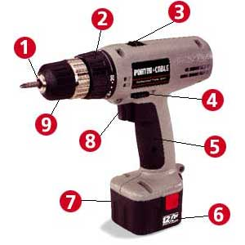Most power drills have these basic components in common.

1. Chuck jaws hold bit

2. Chuck collar for manual tightening. May be replaced by chuck key. See below.

3. Reverse direction

4. Speed dial

5. Trigger

6. Battery release

7. Battery

8. Trigger lock

9. Chuck collar

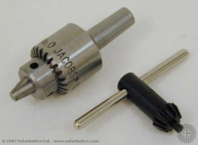On many variable drills, the harder you pull the trigger the faster the speed. Fixed speed drills are, as the name implies, constant in speed. Variable speed drills are more versatile as they can also have screwdriver bits inserted for use as an electric screwdriver. Drills usually have a switch to reverse the drill if the bit becomes stuck in the wood or other material being drilled. Most of the bits we examined in the last unit also work with power drills. The chuck jaws play an important part in holding the bit tight and in line with the drill. A loose bit is dangerous and will do a poor job. Inspect the jaws with each use to make sure they can still grip tightly. Larger drills allow you to drill into concrete or to drill larger diameter holes in metal.

**3.2.2 How to Use a Power Drill**

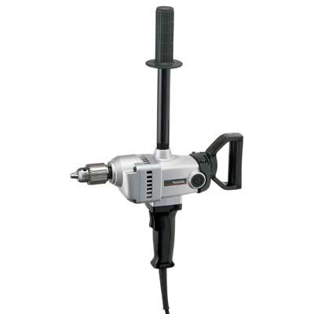

1) Disconnect the power.

2) Insert the bit shank into the chuck jaws.

3) Tighten the jaws by hand until they have contact with the shank. Make sure the bit is straight. Finish tightening the jaws using a key if one is supplied.

4) Check the electric cord and ensure the drill is clean and ready to be used.

5) Plug the drill into a power source.

6) Firmly grip the drill by the pistol grip and gently press the trigger to ensure the drill is working correctly.

7) Proceed to your work holding the drill perpendicular to the work surface.

8) Know what is behind what you drill. Drilling through the wood into wiring or what is behind can cause damage and is a hazard to you.

**3.2.3 Electric Drill Press**

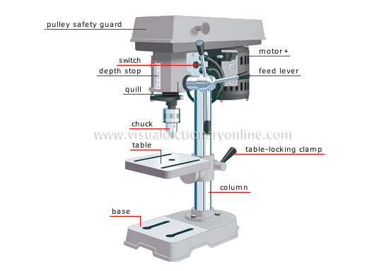

A drill mounted on a frame is called a drill press. The frame allows for more accurate depth and placement than could be done by hand. Also, some operations require heavy pressure which can be applied by the drill press. The table can be adjusted up and down. The quill moves up and down and can be fed forward up to 12" allowing you to boar much deeper holes.

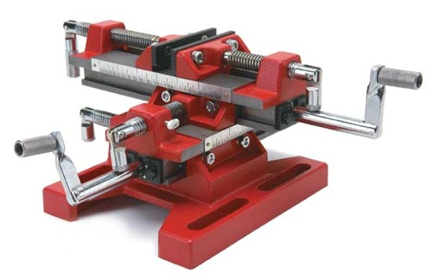As the drill press operates over a wide range of speeds, many different materials can be drilled; holes can even be drilled into glass. The table is also slotted allowing you to attach a fence or various braces. This allows for far greater accuracy and for you to produce parts that are identical. Large drill presses called mills allow you to form or mold many parts and extend the range of what you can do by shaving away small amounts of metal with each pass. The mill usually has a moving mill table that you can use to make very accurate movements under the bit. A mill can put intense pressure while the drill bit turns slowly. Drill presses can be mounted horizontally for unlimited boring of holes with long bits.

**3.2.4 Electric Screwdriver**

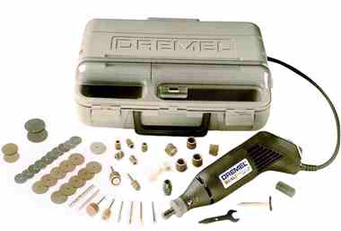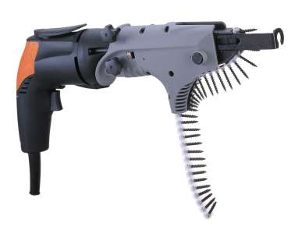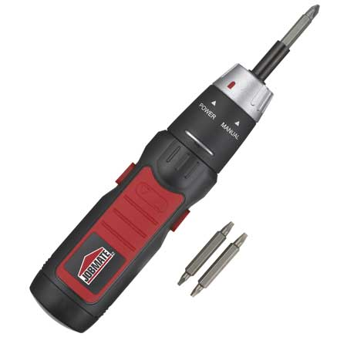An electric screwdriver is probably one of the most used power tools about the home and in many small projects. They come with batteries that hold various voltages. The larger the voltage, the longer the drill will hold a charge. Electric screwdrivers also come with various power settings in amps. The higher the amperage, the more torque the screwdriver can produce. The electric screwdriver does not necessarily work by battery power. Special drivers like the one pictured are preloaded with drywall screws but need an electric cord for power.

Electric screwdrivers come in many sizes for many specialized uses. The small pin driver is used in the hobby market to drill very small holes with great precession. This small drill is called a Dremel tool and, as you can see from the picture, can be used to polish, grind, and sharpen.

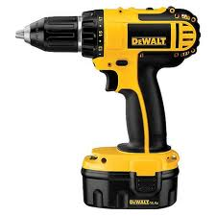

**3.2.5 Cordless Drill/Screwdriver**

Cordless drills are popular at work sites where electricity is not available or it is not convenient to pull an extension cord. The DeWalt power drill shown is one of the most popular. Most cordless drills do not have a chuck key but have a kneeled chuck collar for tighter gripping of the bit. The battery pack can be removed and placed into a charger. It is a good idea to carry an extra battery with you. Knowing how to maintain the battery is also important. Some chargers can recharge the battery in less than an hour, but most require overnight charging to be fully effective.

**3.2.6 Hammer Drill**

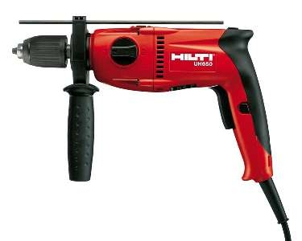

Another type of drill combines the drilling action with a pounding action, moving the bit back and forth while it spins. This allows you to drill into materials such as concrete, brick or tile. When you buy a hammer drill, it has to be tough enough to take this pounding. A cheap hammer drill may not last through its first job. You can usually adjust both the speed of the drill and the rate of the hammering. Hammer drills usually have a second handle, allowing you to put more pressure on the material. They also usually have a depth gauge to protect the hammer drill from going too deep.

**3.2.7 Drill bits**

Lastly, we need to address the bits used in electric drills. Examine the shank. Since they are all uniformly round, they will wear down much more quickly than those used in a hand drill. The chuck jaws come loose more easily, and you will need to retighten the bits often. The bits also become dull faster. Bits need sharpening on a regular basis. Small electric bit sharpeners are available for this job. If you test a bit in the drill and it wobbles, it is not seated straight in the chuck and needs to be loosened and reset so it spins in line with the drill.

**3.2.8 Saws**

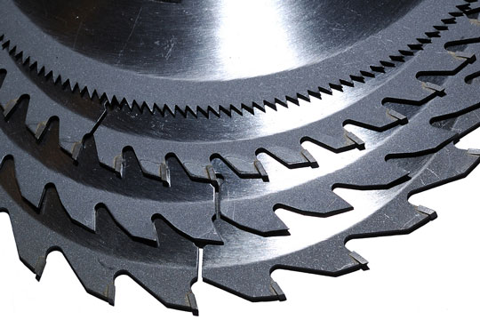A power saw is a just a blade mounted to a motor. The blade you use is important. You need to use the correct blade for the type of material you are cutting. Most saws turn the blade in a circular motion, but others move the blade back and forth (reciprocal motion). Choosing the right saw for the job makes the work go quickly. The wrong choice can be dangerous and will give you poor results.

Look at these blades. Notice the difference in this picture. The same rules apply for power saw blades as were true with hand saw blades. The finer, smaller teeth (or more teeth per inch) allow for crosscutting of wood. The more aggressive teeth patterns are used to rip (with the grain). There are also general-purpose combination blades that do both.

The top blade (above) has 80 tpi and is used in finish crosscut work and cutting plywood. The second and third blades down are 20 to 30 tpi blades and are used for ripping wood, while the last blade is a combination blade for general use. The same is also true with straight blades used in reciprocal saws. There are even finer (greater tpi) blades which can be used to cut metal and special blades for materials such as concrete.

**3.2.9 Circular Saw (Skilsaw)**

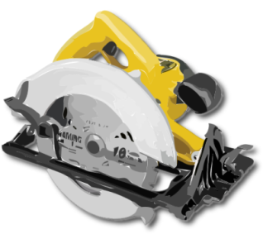A circular saw (most commonly called a Skilsaw) is a common power tool at a jobsite. It is also one of the most dangerous. These circular saws are used to cut lumber to length as well as to rip plywood down to size. These saws come in various sizes, measured in the diameter of their circular blade. The most common size is 7-1/2 inches, but they range from 3-1/2" to 16-1/2" in diameter. The blade needs to be inserted so that it turns in the direction the teeth are pointing. The blade is protected by a guard both above the blade and beneath the blade. The lower guard is spring loaded and moves out of the way as you cut. Never use a circular saw unless both are in place. Most blades cut a 1/8" kerf, and you need to plan ahead for the waste removed by the blade.

The circular saw has a handle with a trigger. The blade usually turns as a constant speed when the trigger is depressed. Circular saws are electrical hazards. It is very common to cut your own electrical cord. The blade will continue to spin after the cut due to momentum, and setting the saw down with the blade in motion causes many accidents. Watch very carefully where you put your hands; always have both on the circular saw. A free hand allows for a finger to stray into the saw's path.

**3.2.10 How to use a circular saw:**

1) Make sure you are wearing your personal protective gear, especially eyewear.

2) Inspect the saw to ensure the cord is not damaged and both guards are working properly. The blade should be tight before you plug it in.

3) Mark your work so you know where to cut.

4) Set the guide properly to cut where you intend.

5) Make sure you know what is behind what you are going to cut.

6) Plug in the saw and test to make sure it is working properly before you begin working.

7) Grip the saw with **both** hands. Remember, a free hand is a target for the saw. Stand to the side of your work, never directly behind the saw.

8) Notice the notch plate shows where the saw will cut. Align this notch with your mark on the work.

9) Start the saw and move slowly into the work. Look ahead of the blade to guide the work. Do not force your work or allow it to burn the wood. Stop cutting, move back, and restart.

10) As you finish the cut, move the blade through the finish smoothly, and then release the trigger switch.

11) Do not set the blade down before it stops moving.

**3.2.11 Compound Miter (chop saw)**

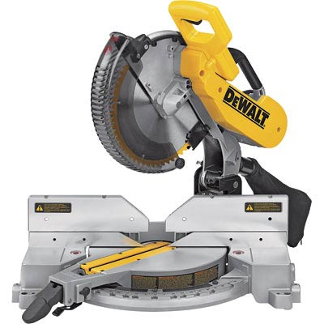One of the most common sounds on most jobsites is the sound of a chop saw winding up or down. Its use is to quickly cut a board to length across the grain. It has only a very limited ability to rip cut. The name compound miter saw comes from its construction: A combination of a circular saw with a miter box. The saw can be tilted to cut at an angle, and the table fence can be turned to create wedge shaped cuts.

To use the saw, measure the wood to be cut accurately (measure twice; cut once). You can bring the saw blade down to the wood prior to starting the motor to see exactly where the kerf will be. Many saws have a laser that projects a line where the cut will be made. The blade will usually have a higher tpi since most of the cutting is across the grain.

When you measure wood, make sure to place your mark on the waste side. Making the kerf in the waste assures that your measurement is accurate. These saws often will have 1/8" (hollow ground blade) or 1/16" (flat blade) wide kerfs and placing the saw on the "good" side will make your final board length short by the width of the blade.

Safety with a chop saw:

1) Make sure you are not wearing loose fitting clothes and are wearing all personal protective equipment, especially eye protection.

2) Know where you plan to cut before you begin.

3) Inspect the saw and its electrical cord for damage. Make sure both blade guards are in place.

4) Make sure the saw is sitting on a firm level surface.

5) Grip the handle and squeeze to start the saw and allow it to come up to full speed before you begin the cut.

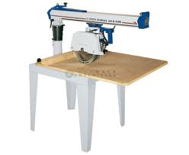6) Never make adjustments while the saw is running and never leave the saw until the blade stops. Make sure your free hand is well away from the cutting area and blade. Hold the saw with both hands.

7) If you are cutting a long board, make sure the far end is supported. Otherwise, when you make a cut the board will fall into the work area.

A similar but larger related saw is the radial arm saw. It does not make angle cuts but is more useful for ripping and quick crosscuts. The movement is along the arm in a linear fashion. The operation and rules are the same. Never move your hands or leave the saw until the blade stops running.

**3.2.12 Table Saw**

In working with wood, one of the most used pieces of power equipment is the table saw. This configuration with the saw beneath the surface allows you to work with larger pieces of wood and make much more complex cuts. With the blade projecting upward, the table saw has gotten a reputation for removing fingers and can be very dangerous, especially around loose fitting clothes. It can grab a piece of cloth into the blade in a fraction of a second, too fast and with too much force for you to be able to react or pull back.

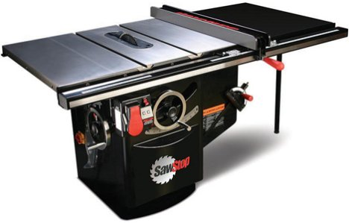A table saw has a fence for ripping which ensures a straight line is cut. It also has a miter gauge for crosscutting of wood. It has the advantages of a miter saw in that either the blade will tilt or the table top will tilt, allowing you to make cuts at a wide variety of angles. **This picture shows the fence. Notice the blade is exposed. This is for the picture only. *Never use a table saw without both the upper and lower guards in place.***

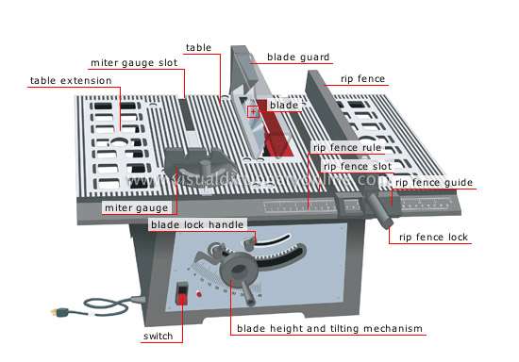

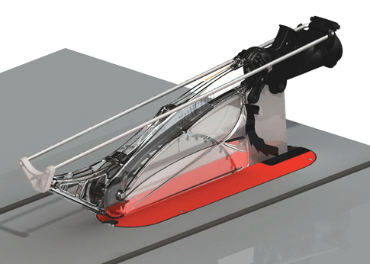This second picture shows the guards and various parts of the table saw. In this model, the blade can be tilted. Notice the fence used for ripping ensures a straight cut while the miter gauge supports the wood for a crosscut. Never stand directly in front of the blade as it can throw the waste piece of wood back at you. The blade guard (shown here) has fingers to protect the good piece of wood from kicking forward.

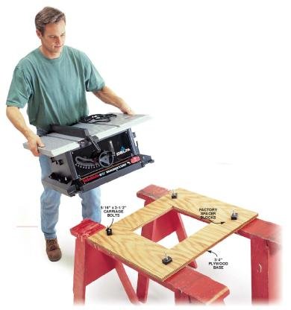

As you can see, a table saw comes in many sizes and can be portable. Make sure that it is sitting on a level, sturdy surface.

**3.2.13 Reciprocating Saw (Sawzall)**

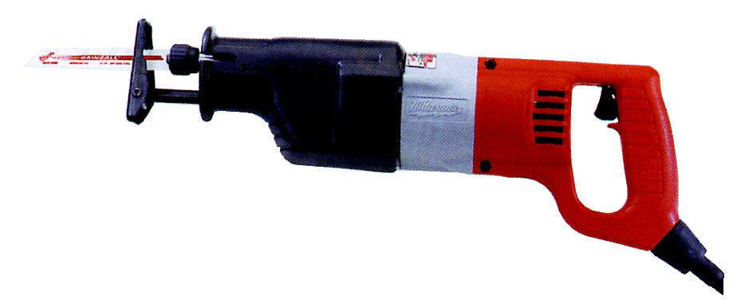In deconstruction, a Sawzall is very useful tool that makes tearing apart a structure quicker. The Sawzall (as its name implies) can cut through various materials such as nails in wood. Notice how the blade is changed and the saw has a reciprocal motion (in and out). This saw is intended to be used with two hands. It is heavy and, with the blade exposed as shown, it is quite dangerous. ***You must know what is behind what you intend to cut.***

Many accidents happen as the Sawzall cuts through electric lines or water pipes unintentionally. This can be a hazard and also turn a small job into a major project.

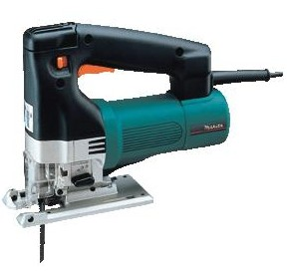A smaller version of the reciprocating saw is called a jigsaw. Its primary use is to make curved and complex cuts. It can be easily turned while cutting.

Both the Sawzall and jigsaw can be fitted with a wide variety of blades to cut various materials, both ripping and crosscutting. There are also high tpi blades available to cut metal and countertops such as simulated marble. Finding the proper blade for the job is the trick to getting good results.

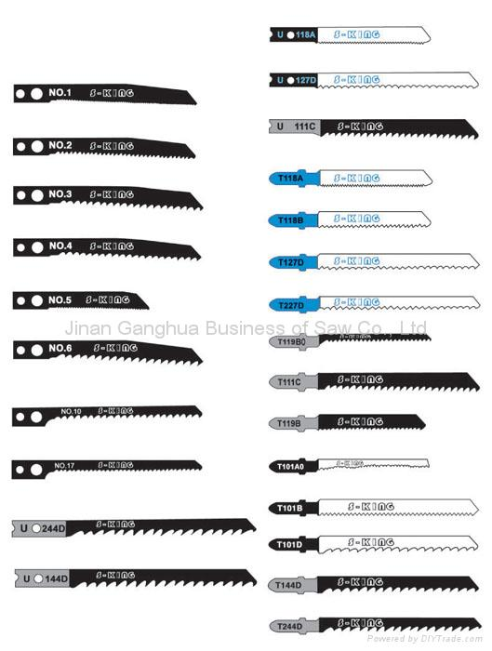

**3.2.14 Saw Blades**

Notice that the blades must both match the saw you intend to mount them in and also match the material you wish to cut. The same rules apply: Lower tpi blades such as 6 to 8 are for ripping wood. Higher tpi such as 15 to 20 are for crosscutting and even higher tpi for cutting various harder materials such as metal.

The Sawzall has combination blades. These are used when you know you will be cutting a wooden structure apart but may encounter a nail.

**3.2.15 Electric Sander**

Once the wood is rough cut, you may need to sand the edges to prevent slivers and wood splitting out of the finished structure. Sanders come in many different styles and motions. A circular sander moves the sandpaper in a circular motion, a reciprocating sander in a back and forth motion, and a belt sander takes a belt of sandpaper and spins it. Each has its place. Always keep both hands on the sander as shown. 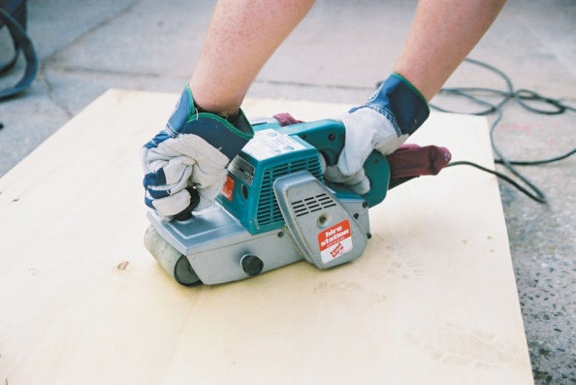If you do not, you will join many of us who have sanded skin off of our free hand. The larger sanders can rip the skin very quickly. Again, it is a power tool and commands respect. Some belt sanders are mounted on a power stand and can hold larger belts 4" to 8" wide for quicker work.

Sandpaper is measured in grit. The higher the grit number, the finer the material on the paper. 60 to 80 grit paper is used for rough sanding, 120 to 160 grit for finish sanding. Grits go up as high as 1200 grit used to polish metal in the automotive repair business.

Sandpaper comes mounted in many different ways for various types of sanders.

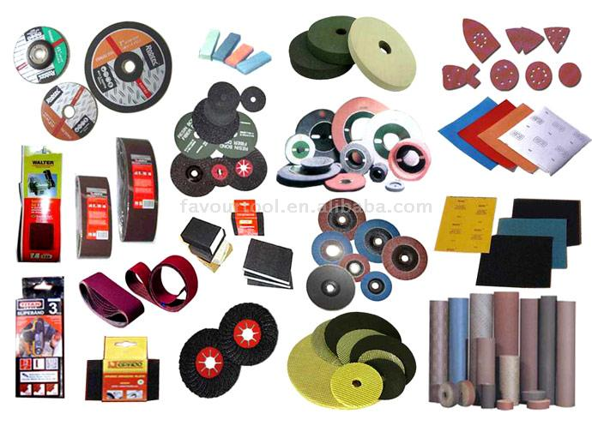

**3.2.16 Pneumatic Nail Gun**

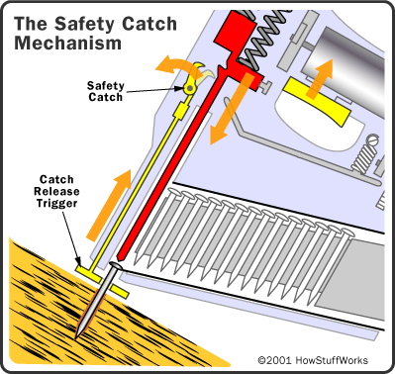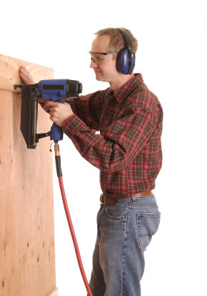Pneumatically powered nail guns are common in the trades and great time savers. The compressed air literally shoots the nail into the wood, greatly speeding up the work. Nail guns come in various sizes according to the size nail being used. They fire when both the front nozzle is in solid contact with the work surface and the trigger is pulled. This dual action is an important safety feature. The high pressure in the air hose also creates a hazard as the nail can be shot through the wood into something behind the scene such as a fellow classmate. These tools must be used with extreme caution.

For safe use:

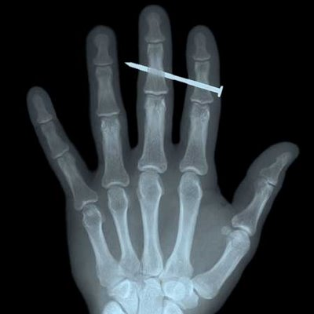1) Inspect the nail gun before you attach the air hose and make sure it has been oiled with each use.

2) Know what is behind where you intend to nail. Mark the studs with a chalk line.

3) Make sure you have read the manufacturer's instructions and know how to use the gun before you try. Always ask if you are unsure, as there are many different styles and manufacturers.

4) Make sure the nails are matched to the nail gun. They are not interchangeable. The wrong type of nail will jamb in a nail gun.

5) Connect the hose and make sure there is not an air leak at the connection. Make sure the air hose is free and you have ample length for the job.

6) Test fire a nail into a piece of scrap wood to make sure the nail penetrates flush with the wood. Nail guns run between 70 and 120 psi (pounds per square inch). Too much pressure will push the nail too far into the wood; too little pressure and the nail head will project, requiring additional nailing.

7) Hold the nozzle tight against the wood and compress the safety release. Then, press the trigger.

8) Disconnect the air hose before you set the nail gun down. Never leave a nail gun connected or unattended.

**3.2.17 Air Compressor**

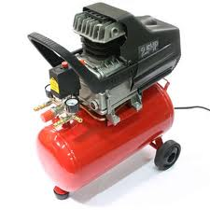

Many of the industry tools you will use will be powered pneumatically (by air). We also use air to clean up sawdust around the work site. An air compressor will be at most jobsites.

You need to know how to adjust the air pressure to the tool and how to drain water from the tank. The air compressor takes air from the environment which contains moisture. This condenses in the tank and causes it to rust quickly if not removed each day.

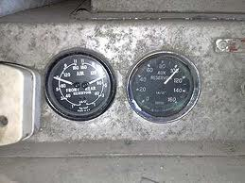Most air compressors have two valves and gauges. The one on the left is the pressure that the air compressor maintains. When the pressure drops, the compressor will start its electric motor to store more air. This is usually set at 120 psi. The gauge on the right is the amount of air pressure to the power tool. It should be set according to the tool manufacturer's specifications. Beneath each gauge is an adjustable valve handle that allows you to set it.